Experiments on the focusing and use of acoustic energy to accelerate polymer healing

Alexander J. Cushmana , Brian C. Fehrmana , Shaun D. Grueniga , and Umesh A.
Kordea
a South Dakota School of Mines & Technology, 501 E. St. Joseph St. Rapid City, SD 57701, USA

ABSTRACT

In this paper, we cover our studies on accelerating the molding process of a polymer by applying acoustic stress-wave time reversal. Tests carried out on an epoxy polymer mixed with a curing agent have shown evidence that the introduction of unfocused acoustic energy during the molding process will accelerate that process. The effects of focusing acoustic energy at a mold discontinuity while curing are explored. We also detail our investigations on focusing acoustic energy at a crack location by iteratively applying time reversal. Multiple types of media were tested.

Keywords: Self healing, Time Reversal, Crack Healing, Polymer Curing

1. INTRODUCTION

The costs associated with traveling to repair most structures is not a high concern. When it comes to space structures, however, travel becomes a higher concern. Satellites and lightweight space structures are constantly being bombarded by micro-meteoroids and space debris which can cause surface damage in the form of cracks. It is estimated that over 100 billion meteoroids larger than a microgram enter the atmosphere of the Earth everyday. This means that space structures are subject to a high chance of collision with many meteoroids. Damage can also come in the form of impact from space debris. There are over 20,000 trackable space debris objects exceeding a size of 10cm that are in orbit. Surface damage to the structures caused by object impact is nearly inevitable. In addition to high cost and danger of traveling to repair the space structure, there is also the possibility that more space debris will be left behind and further increase the chances of damage to the structures in orbit. For these reasons, it is very desirable to have a structure with the ability to autonomously repair its surface damage.1, 2
Self healing materials have been receiving a lot of attention lately. The idea is to apply the biological concept that when a wound occurs the organism will automatically begin to mend itself back together.3 One implementation is to have a material containing two types of micro-capsules that contain either resin or catalyst. When a crack occurs, the two fluids will come into contact and begin the healing process.4–6 The rate of healing needs to occur rather quickly because the crack will attempt to continue expanding while the healing process is taking place. If the rate of crack expansion exceeds the rate of healing then a full recovery may never be achieved.
There are many methods that have been researched in order to speed the rate of recovery. Much of this work has focused on solving the problem from a materials stand point.7–12 Vary- ing the size of the micro-capsules to maximize the healing rate is one example.13 Varying the temperature or exposing the material to ultraviolet light are other examples of ways to speed the healing process.14–19 Wool and O’Connor have found that the recovery rate can be accelerated by increasing the pressure at the recovery site and more recent work supports this concept.20, 21

Further author information: (Send correspondence to Umesh A. Korde) U.A.K.: E-mail: umesh.korde@sdsmt.edu, Telephone: 1(605) 394-2401

We wish to apply acoustic stress waves to increase the localized pressure at a healing site and, in turn, increase the rate at which the material recovers.
It would be inefficient to blindly send acoustic energy throughout the system in a continuous fashion whether or not damage has occurred. Not only will this unnecessarily consume a large amount of power, it also has the potential to resonant within the structure and cause damage. Therefore, it is desirable to have a system that is able to detect when damage occurs and then begins to focus acoustic energy at that damaged location. This focusing would be done without actual knowledge of the crack’s location. Acoustic time reversal is one such method that could be used. Many variations and applications of time reversal have been studied.22–31 One method is to iteratively apply time reversal such that a better focusing of the acoustic energy at a crack location is achieved with each iteration.
In this paper we detail our latest studies on using acoustic energy to accelerate epoxy curing. We have performed more tests using a two-part epoxy. These tests involve monitoring the curing rate of the epoxy with and without acoustic energy being introduced to see if there is an effect. Iterative time reversal has also been carried out on both dispersive and non-dispersive rods. The goal of the time reversal was to focus energy and increase the response amplitude at a “defect” location within the rod system over a number of iterations.

2. EXPERIMENTAL IMPLICATIONS

We have broken the overall project into two main components for us to study. The first component is determining the relationship between acoustic excitation and the curing rate of a self healing material. Wool and O’Connor have also shown that the processes of a self healing material mending itself and an epoxy curing can be treated the same. This is due to the fact that both substances will traverse the same five steps during their curing process which are: (i) surface rearrangement, (ii) surface approach, (iii) wetting, (iv) diffusion, and (v) randomization. Experimentally, we look at the curing process of a two part epoxy with and without excitation from a speaker.
Focusing of acoustic energy is the second component of the project. It is needed to efficiently increase the healing rate at a crack location. Time reversal experiments have been carried out using new setups involving multiple types of media. These tests are used to determine the effectiveness of the time reversal algorithm in focusing the energy of the acoustic waves.

2.1 Epoxy Curing Experiments
Over the last two years, the epoxy curing project’s setup and experiments have remained mostly unaltered. A two-part epoxy is used to fill a brass tube and the curing process is then monitored. To monitor this process, two sensors are used: a thermistor which rests inside the curing epoxy to provide temperature feedback, and an accelerometer attached to the brass tube to record a vibrational response. These vibrations are generated by a marble dropper which is positioned over the tube. We plot the FFTs of these vibrational responses and use them to characterize the state of the cure process. The idea is that the response will change as the epoxy cures. This setup is kept in a temperature-controlled container, which provides more consistent results. Using the LabVIEW programming environment, new software has been made for acquiring data which allows more reliable testing and easier data manipulation. New hardware is also being used which gives greater control over the data acquisition process.
In these experiments, we compare the rate of curing with and without acoustic excitation. This excitation is created using a simple setup: a speaker is placed on top the box which houses the experiment. Figures 1 and 2 show the experiment’s current configuration(without the marble dropper or container).

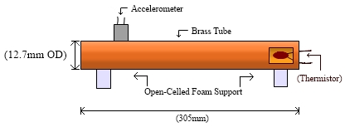

Figure 1. The dimensions and setup for experiment which monitors the curing process of the epoxy without the use of acoustic excitation
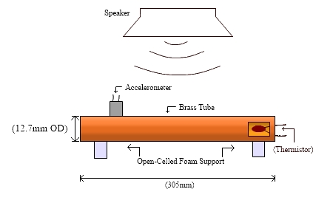

Figure 2. The dimensions and setup for experiment which monitors the curing process of the epoxy. This time, however, acoustic energy is being introduced into the system.

2.2 Iterative Time Reversal Experiments
The idea is to focus acoustic wave energy at a crack location within a system. For these experi- ments, we use a system of solid, circular rod segments. Ultrasonic waves are propagated through these rods using ceramic piezoelectric transducers (PZTs). These same transducers are also able to acquire signals based on their response to acoustic excitation. Two rod segments are used in these experiments. A PZT is sandwiched between the ends of these two rods in order to form a “crack” in the system and also read the response at that point. We will refer to this as the crack PZT. A PZT is then placed on each open end of the system and everything is compressed. We will refer to these end PZTs as Ch0 and Ch1. This system is shown in Figure 3.
One of these end PZTs (Ch0, for this example) will send a short signal through the rod system.

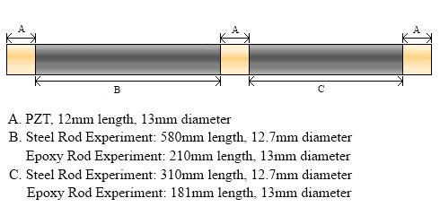

Figure 3. Overview of the setup and dimensions for the iterative time reversal experiments

When this signal reaches the crack PZT, part of its energy will reflect back to the sending PZT (Ch0) and part will continue propagating to the PZT on the opposite end of the system (Ch1). If the end PZTs (Ch0 and Ch1) capture, amplify, and replay these waves in a time reversed fashion, then they will recombine at the location where they split. This location is the site of the crack PZT and we will achieve a focusing of energy at that location. This process is then applied iteratively. With each iteration we see a better focusing of the waves and an increase in amplitude at the crack PZT. The gains eventually level off and we considering the algorithm has having converged. Between each iteration, we also introduce a delay time. This allows for the residual vibrations in the system to die down. Waiting for the ringing to subside will help to prevent the system from resonating and becoming damaged.
These tests were carried out using two different types of rods. The first were a set of steel rods. These provided a nice transmission of the waves and eased the analysis. The other set of rods tested were brass rods filled with epoxy. This epoxy has been left to fully cure before testing of the time reversal algorithm. These brass rods proved to be much more dispersive than the steel rods. Due to this reason, a slightly different method of time reversal was used for these experiments than what was described above. Both time reversal algorithms are detailed in Figure
4.

3. EXPERIMENTAL RESULTS
3.1 Results of Epoxy Curing
After using the accelerometer to record the vibrational response from the collisions of the marbles with the brass tube as previously discussed, we are able to plot the FFT of this response. As the curing process elapses, the frequencies that the epoxy has the greatest response to will shift, as seen in Figure 5. This figure also shows that the amplitudes of these peaks shift as well. Comparing the peaks on the FFT plot at any given point in the curing process to the peaks on the FFT plot of the fully cured sample is used to determine the progress of the curing process at that point. This is used to compare the curing rate of the epoxy with and without acoustic

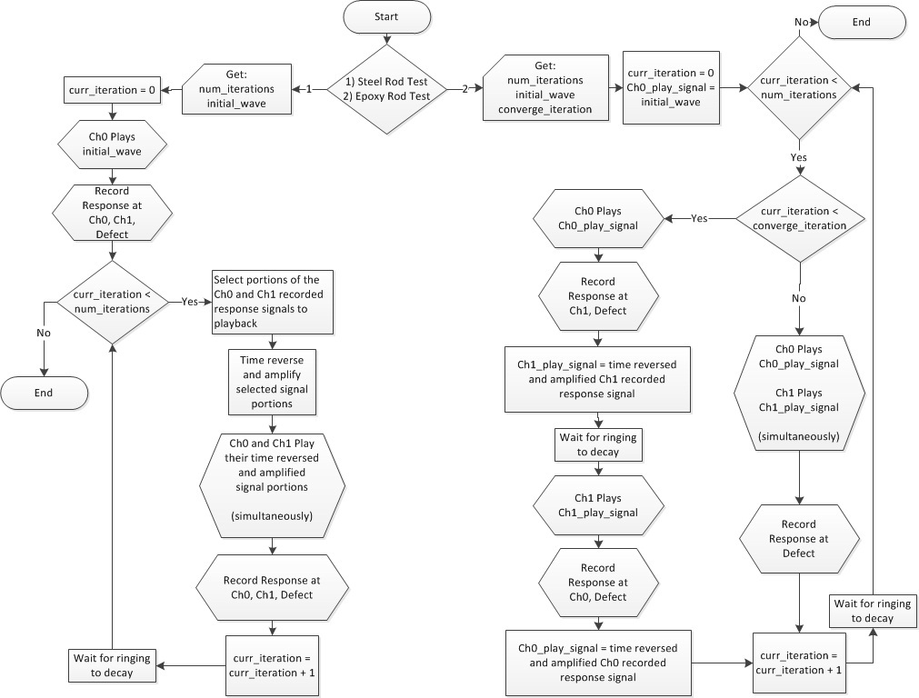

Figure 4. Flowchart detailing the iterative time reversal algorithms used for each rod system, with the algorithms differing just slightly between the steel rods and the epoxy-filled brass rods

excitation. Figure 5 shows one such FFT plot, where the lighter plot shows the vibrational response of the epoxy without acoustic excitation after two hours and the darker plot shows the response after the epoxy has fully cured. Figure 6 shows the same FFT plots, but with the introduction of acoustic energy to the system. As shown by these plots, it appears that the acoustic energy introduced succeeds in accelerating the curing process of the epoxy.

3.2 Results of Iterative Time Reversal
The iterative time reversal produced fairly good results for both rod system. With both the steel and the epoxy-filled brass rods we were able to get an increased response amplitude at the crack PZT location. Figure 7 shows the results for the experiment performed on the steel rod system. Six iterations are plotted. The response produced at the crack PZT is seen to be considerably higher on the final iteration than on previous iterations.
Analysis was performed in order to predict the response at the crack PZT. This was compared to experimental data. A reasonable match is seen between the two. This is shown in Figure 8.
Results similar to those seen with the steel rods were obtained in the epoxy-filled brass tube experiments. We see an increased response at the crack PZT as the iterations of the time reversal progress. Even with the high dispersion of the epoxy, we are still able to achieve a level of focusing at a point within the system. The results of the epoxy rod tests can be viewed in Figure 9.

4. CONCLUSIONS AND FUTURE WORK

The results of our epoxy experiments suggest that the presence of acoustic energy will accelerate the curing process of the epoxy. There is a strong evidence from the time reversal experiments

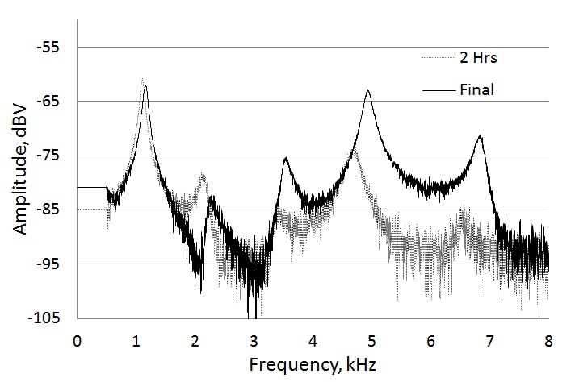

Figure 5. FFT of the vibrational response at 2 hours and 24 hours of the curing process for the epoxy-filled brass rod without acoustic excitation.
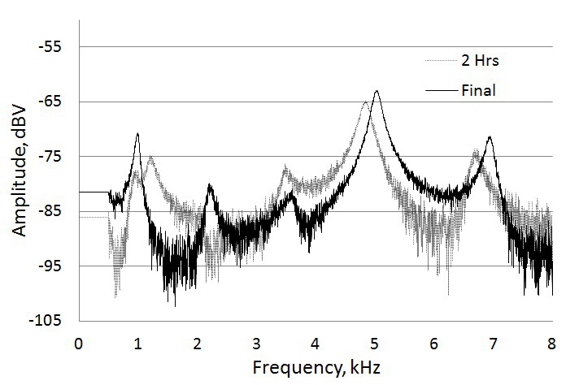

Figure 6. FFT of the vibrational response at 2 hours and 24 hours of the curing process for the epoxy-filled brass rod with acoustic excitation being introduced.

that we can increase the pressure at a crack location by focusing acoustic waves at that point. If we apply the time reversal iteratively then we are able to achieve an even better focusing at the crack site. Analytical results have a decent match to the experimental results for the steel rod tests. Both dispersive and non-dispersive media were tested and both showed good results.

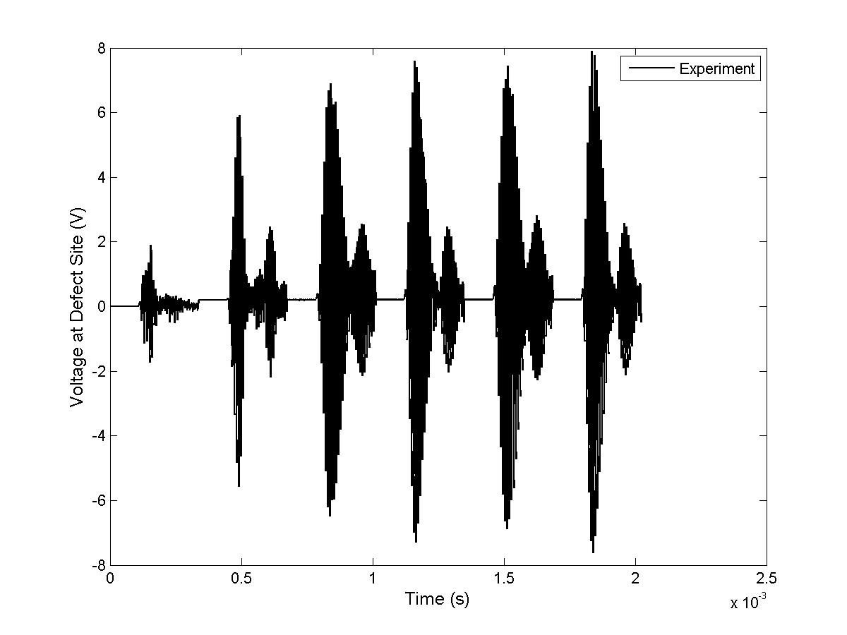

Figure 7. Graph which shows the response at the crack PZT for the steel rod system when using the iterative time reversal algorithm. Multiple iterations are plotted. With each iteration, the amplitude of the response increases. Secondary waves are thought to result from the adhesive which is used to better the rods and PZTs. This is being investigated in newer systems.
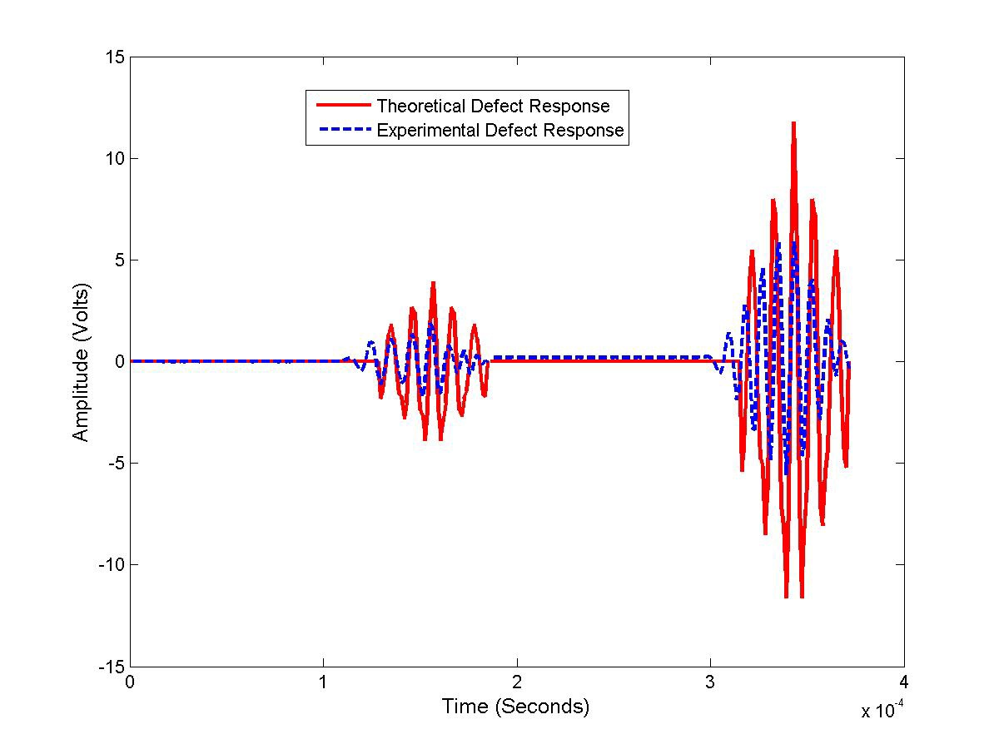

Figure 8. Shows the comparison between the predicted and the experimental response at the defect location. The secondary waves seen in the early graph have been omitted.

Future tests will involve further verification of the affects of acoustic energy on epoxy curing. We will also attempt to use iterative time reversal in order to fuse nylon rod segments together. Tests

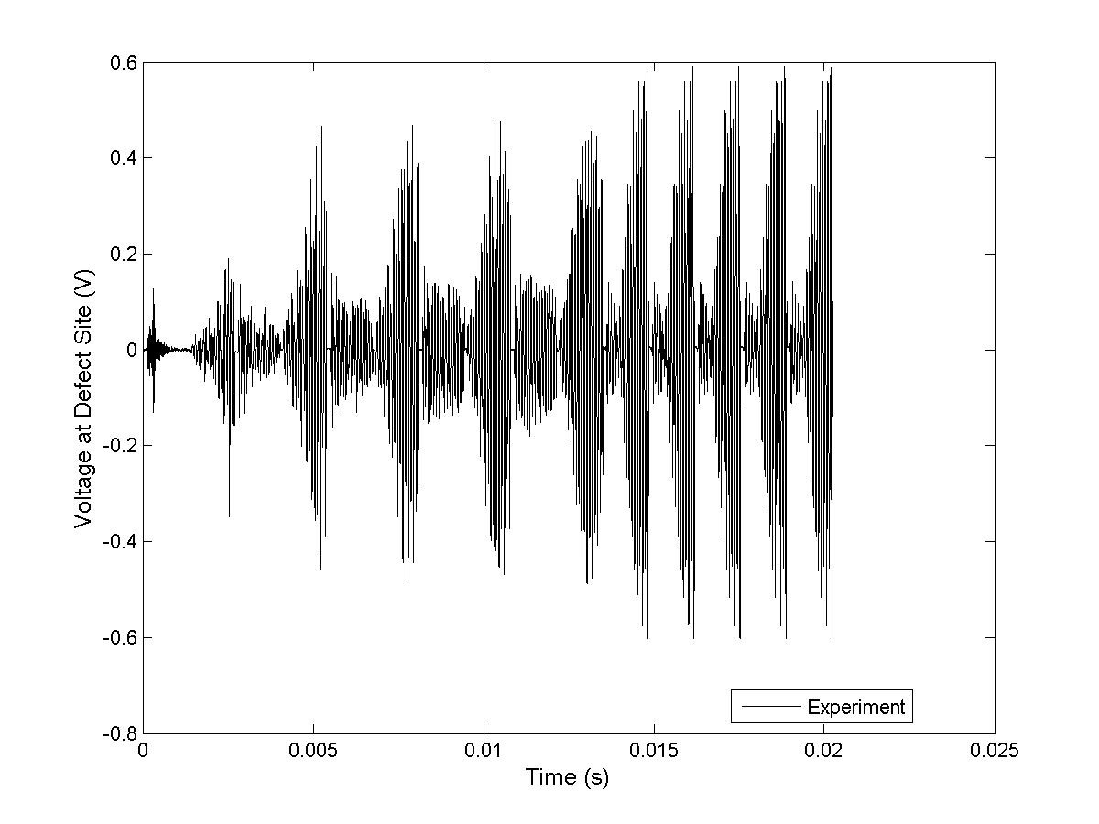

Figure 9. Amplitude of the response at the crack PZT for multiple iterations of the time reversal algorithm. The amplitude appears to increase throughout the iterations.

will also be carried out which will put the epoxy curing and time reversal experiments together in order to enhance the curing speed of the epoxy.

ACKNOWLEDGMENTS

We would like to thank the Air Force Research Laboratory for their continued support and also acknowledge Joe Harley and his team from Carnegie Mellon for their input on the project.

REFERENCES
[1] Close, S., “Space invaders,” IEE Spectrum 47 (2010).
[2] Lee, B., “Multifunctional design perspective for self-healing and autonomic response,” Final
Program and Abstract Book 2nd ICSHM - 28 June - 1 July 2009.
[3] White, S. R., Blaiszik, B. J., Kramer, S. L. B., Olugebefola, S. C., Moore, J. S., and Sottos, N. R., “Self-healing polymers and composites,” American Scientist 99, 392–399 (2011).
[4] Mangun, C. L., Mader, A. C., Sottos, N. R., and White, S. R., “Self-healing of a high temperature cured epoxy using poly(dimethylsiloxane) chemistry,” Polymer 51, 4063 – 4068 (2010).
[5] White, S., Sottos, N., Guebelle, P., Moore, J., Kessler, M. R., Sriram, S., Brown, E., and
Viswanathan, S., “Autonomic healing of polymer composites,” Letters to Nature 409, 794–
817 (February 2001).
[6] Yuan, Y. C., Chen, J., Yang, G. C., Li, X. M., Rong, M. Z., and Zhang, M. Q., “Self-healing polymetric materials using epoxy/mercaptan as the healent,” Macromolecules 41, 5197–5202 (2008).
[7] Sheng, X., Mauldin, T. C., and Kessler, M. R., “Design and synthesis of next-generation monomer healing agents,” Final Program and Abstract Book 2nd ICSHM - 28 June - 1 July
2009.

[8] Burattini, S., Greenland, B. W., Colquhoun, H. M., and Hayes, W., “A rapidly healable supramolecular polymeric blend,” Final Program and Abstract Book 2nd ICSHM - 28 June
- 1 July 2009.
[9] Nakao, W. and Abe, S., “Self-healing rate improvement by shape modification of dispersed silicon carbide particles,” Final Program and Abstract Book 2nd ICSHM - 28 June - 1 July
2009.
[10] Fettig, J. W. and Freund, J. B., “Multi-phase simulation of microvascular self-healing ma- terials,” Final Program and Abstract Book 2nd ICSHM - 28 June - 1 July 2009.
[11] Imperiale, V. A. and Bond, I. P., “A novel self-healing agent able to improve the residual strength of cfrp after impact,” Final Program and Abstract Book 2nd ICSHM - 28 June - 1
July 2009.
[12] Zhang, C.-S. and Ni, Q.-Q., “Bending behavior of shape memory polymer based laminates,”
Science Direct - Composite Structures 78, 153–161 (2007).
[13] Rule, J. D., Sottos, N. R., and White, S. R., “Effect of microcapsule size on the performance of self-healing polymers,” Polymer 48, 3520–3529 (2007).
[14] Sloof, W. G., “Self-healing mechanism in material for high temperature applications,” Final
Program and Abstract Book 2nd ICSHM - 28 June - 1 July 2009.
[15] Song, G. M., Pei, Y. T., Sloof, W. G., Li, S. B., van der Zwaag, S., and Hosson, J. T. M. D., “Oxidation-induced crack healing in T i3 AlC2 ceramics,” Final Program and Abstract Book
2nd ICSHM - 28 June - 1 July 2009.
[16] Bosman, A. W., “Supramolecular materials in motion,” Final Program and Abstract Book
2nd ICSHM - 28 June - 1 July 2009.
[17] Djugum, R. and Lumley, R. N., “Healing and crack closure in an Al-Cu alloy by remedial heat treatment,” Final Program and Abstract Book 2nd ICSHM - 28 June - 1 July 2009.
[18] Murphy, E. B., Auad, M. L., and Wudl, F., “Stimuli-responsive healable materials: Diels- alder based mending,” Final Program and Abstract Book 2nd ICSHM - 28 June - 1 July
2009.
[19] Garcia, A., Schlangen, E., and van de Ven, M., “Closing cracks on conductive asphalt mortar by induction heating,” Final Program and Abstract Book 2nd ICSHM - 28 June - 1 July
2009.
[20] Wool, R. and O’Connor, K., “A theory of crack healing in polymers,” J. Applied Physics 52,
5953–5963 (October 1981).
[21] Sharma, S. and Luzinov, I., “Ultrasonic curing of one-part epoxy system,” Journal of Com- posite Materials 45, 2217–2224 (2011).
[22] Anderson, B. E., Griffa, M., Larmat, C., Ulrich, T. J., and Johnson, P. A., “Time reversal,”
Acoustics Today 4, 5–15 (January 2008).
[23] Anderson, B. E., Ulrich, T. J., Griffa, M., Bas, P. Y. L., Scalerandi, M., Gliozzi, A. S., and Johnson, P. A., “Experimentally identifying masked soruces applying time reversal with the selective source reduction method,” Journal of Applied Physics 105 (2009).
[24] Ambrozinski, L., Stepinski, T., Packo, P., and Uhl, T., “Self-focusing lamb waves based on the decomposition of the time-reversal operator using time-frequency representation,” Mechanical Systems and Signal Processing 27, 337–349 (2012).
[25] Borcea, L., Papanicolaou, G., and Tsogka, C., “Theory and applications of time reversal and interferometric imaging,” Inverse Problems 19, s139–s164 (2003).
[26] Dahl, M. F., Kirpichnikova, A., and Lassas, M., “Focusing waves in unknown media by modified time reversal iteration,” SIAM Journal on Control and Optimization 48 (2009).
[27] Fink, M., Cassereau, D., Derode, A., Prada, C., Roux, O., Tanter, M., Thomas, J., and Wu, F., “Time reversed acoustics,” Rev. Prog. Phys 63 (June 2009).
[28] Foroozan, F. and Asif, A., “Time revesal based active array source localization,” IEE Trans- actions on Signal Processing 59 (2011).

[29] Harley, J., ODonoughue, N., States, J., Ying, Y., Garrett, J., Jin, Y., Moura, J. M., Oppen- heim, I., and Soibelman, L., “Focusing of ultrasonic waves in cylindrical shells using time reversal,” 7th International Workshop on Structural Health Monitoring 2009.
[30] Sinelnikov, Y. D., Sutin, A. M., and Sarvazyan, A. P., “Time reversal in ultrasound focusing transmitters and receivers,” Acoustical Physics 56 (2010).
[31] Sutin, A. M., TenCate, J. A., and Johnson, P. A., “Single-channel time reversal in elastic solids,” J. Acoust. Soc. Am. 116, 2779–2784 (November 2004).

